(ORGANIZATION)
Invites You to a Special Screening of
A short-film documentary about a rising high school senior who sets out
to uncover the growing problem of teens abusing prescription medicine
in his hometown

Followed by a Panel Discussion and Q&A

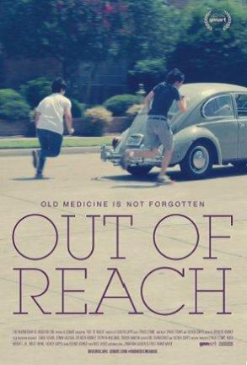
(Date)
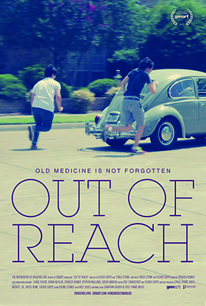
(Location)
(Time)

MODERATOR
(Moderator Name)
(Moderator Title)
(Moderator Organization)

PANELISTS
(Panelist Name)
(Panelist Title)
(Panelist Organization)

(Panelist Name)
(Panelist Title)
(Panelist Organization)

Panelist Name)
(Panelist Title)
(Panelist Organization)

EVENT SPONSORED BY
(List any event sponsors or special thanks here)
*Kindly RSVP by (DATE) to: (EMAIL)

